Flexible Pavement Construction

**Hayden Brett**

Created Tue, 16 Jan 2024, 3:46 PM (UTC+11)

**Subcontractor (if applicable)**

**ITP Details:**

|  |  |  |  |  |  |  |
| --- | --- | --- | --- | --- | --- | --- |
| **Clent** | **Construction Process** | **Contract Number:** | **Speciﬁcations** | **Structure / Component** | **Prepared By** | **Approved By** |
| *Regional Roads Victoria* |  |  | *Vicroads Speciﬁcation Section 173, 175, 205,*  *210, 290, 304, 702 and*  *720, VR Code of Practice 500.2* | *Pavements* |  |  |

**Project Location Lot No.**

**Lot details**

**Lot size/qty**

**Date** Start: - End: -

**Legend:**





1. **Preliminary Works**

|  |  |  |  |  |  |  |
| --- | --- | --- | --- | --- | --- | --- |
| **Task/Activity Description** | **Acceptance Criteria** | **Reference Documents** | **Method & Record of conformity** | **Responsibility** | **Signature** | **Comments** |
| **1.1** SET OUT OF WORKS  **Frequency**  Each lot as required | Ensure relevant construction drawing are being used to determine set-out of works. | Vicroads std sec 100.6 | **Method**: Survey set-out | SCP  SWA Project Manager |  |  |
|  |  |  | **Record**: Signed ITP |  |
|  | Ensure all survey pegs are aligned max 40m apart and the oﬀset distances and heights are in accordance with relevant drawings |  |  |  |
|  | Refence checking to be conducted with string lines |  |  |  |
| **1.2** CONFORMITY WITH DRAWINGS –  Random Level Assessment - Scale B Surface Level Requirements  **Frequency**  Prior to commencing any activity | Level measurements shall be taken at random locations over the area of the lot in accordance with Section 173 – Examination and Testing of Materials and Work (Roadworks). The number of measurements taken within each lot shall not be less than the number speciﬁed in Table  204.031. Random level assessments of the surface shall be undertaken in lots not exceeding 4000 m2. | Vicroads std sec 204.03 | **Method**: Survey Report  **Record**: Signed ITP | IHP  SWA Project Manager |  |  |

1. **Construction works**

|  |  |  |  |  |  |  |  |  |
| --- | --- | --- | --- | --- | --- | --- | --- | --- |
| **Task/Activity Description** | **Acceptance Criteria** | **Reference Document s** | **Inspection method & Record of conformity** | **Responsib ility** | **Signature** | **Reports** | **Photos** | **Comments** |
| **2.1** REQUIREMENTS FOR TESTING AND ACCEPTANCE OF COMPACTION  (a) General  **Frequency**:Each lot as required | Material during compaction shall have a moisture content of not less than 85% of optimum. After completion of compaction of a layer, the moisture content of the material in the layer shall be maintained at a moisture content of not less than 85% of optimum until test rolling has been completed. | Vicroads std sec 304.08 | **Method**: Visual & Laboratory Report  **Record**: Signed ITP | IHP  SWA  Project Manager  **AP**  RRV  Superinten dent |  |  |  |  |

|  |  |  |  |  |  |  |  |  |
| --- | --- | --- | --- | --- | --- | --- | --- | --- |
| **Task/Activity Description** | **Acceptance Criteria** | **Reference Document s** | **Inspection method & Record of conformity** | **Responsib ility** | **Signature** | **Reports** | **Photos** | **Comments** |
| **2.2** REQUIREMENTS FOR TESTING AND ACCEPTANCE OF COMPACTION  (b) Material of Nominal Size 40 mm or Less  **Frequency**:Each Lot | The calculation of density ratio shall be based on tests performed using Modiﬁed compactive eﬀort. The work shall be assessed for compliance with Scale B requirements being not less than 97%. See table 304.081.  For work to be tested for compliance with Scale B requirements, the number of tests per lot shall be six. See table 304.121.  The maximum thickness of any pavement base layer shall not exceed 150 mm and the maximum thickness of any subbase layer shall not exceed 200 mm.  The minimum thickness of any pavement layer shall be 4 times the nominal size of the material. | Vicroads std sec 304.08 | **Method**: Laboratory Test Report  **Record**: Signed ITP | IHP  SWA  Project Manager  IP  SWA Site supervisor  **AP**  RRV  Superinten dent |  |  |  |  |

|  |  |  |  |  |  |  |  |  |
| --- | --- | --- | --- | --- | --- | --- | --- | --- |
| **Task/Activity Description** | **Acceptance Criteria** | **Reference Document s** | **Inspection method & Record of conformity** | **Responsib ility** | **Signature** | **Reports** | **Photos** | **Comments** |
| **2.3** TEST ROLL PAVEMENT LAYER  **Frequency**:Each Lot | The Contractor shall not commence placing any ﬁll on the prepared areas until the area has been reviewed by the Superintendent.  The Contractor shall provide for the Superintendent to be present during all test rolling. | VcRoads Std Specs  173.03 &  204.12 | **Method**: Proof roll  **Record**: Signed ITP & Test Report | HP  SWA  Project Manager  **AP**  RRV  Superinten dent |  |  |  |  |

|  |  |  |  |  |  |  |  |  |
| --- | --- | --- | --- | --- | --- | --- | --- | --- |
| **Task/Activity Description** | **Acceptance Criteria** | **Reference Document s** | **Inspection method & Record of conformity** | **Responsib ility** | **Signature** | **Reports** | **Photos** | **Comments** |
| **2.4** CONFORMITY WITH DRAWINGS –  Random Level Assessment - Scale B Surface Level Requirements  **Frequency**:Each Lot | The surface level of the pavement courses shall be measured in accordance with the requirements of Section 173 and every test lot shall meet either Scale B requirements as speciﬁed in Clause 304.12.  Random level assessments of the surface shall be undertaken in lots not exceeding 4000 m2.  Each level measurement shall be taken at random locations over the area of the lot in accordance with the VicRoads Test Method and the number of measurements taken within each lot shall not be less than the number speciﬁed in Table  304.061. Surface Level Tolerance as per Table 304.062 | VcRoads Std Specs 304.06 | **Method**: Survey report  **Record**: Signed ITP | IHP  SWA  Project Manager  **WP**  RRV  Superinten dent |  |  |  |  |

**Std. References**

Tables:

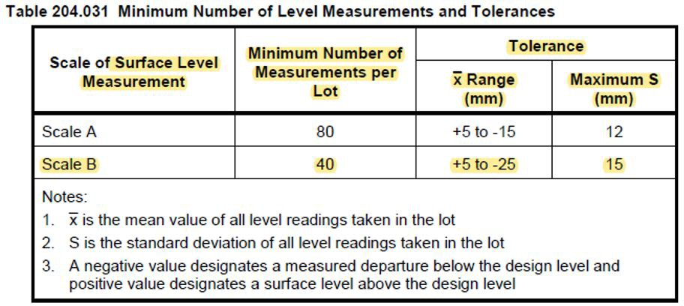

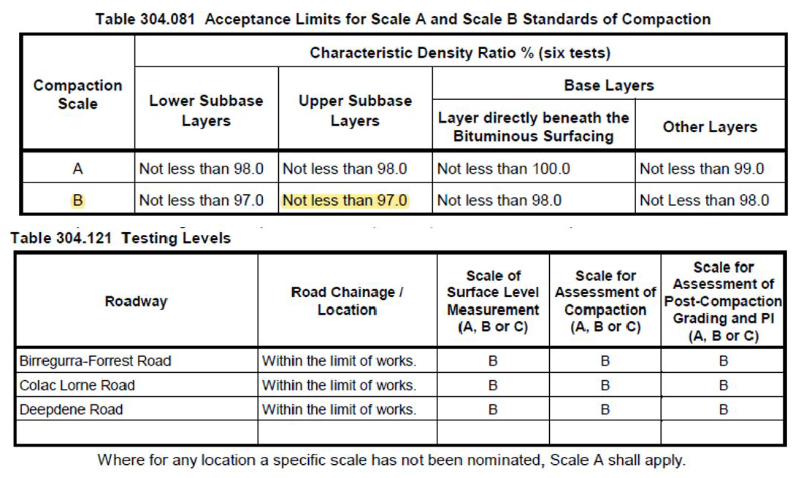

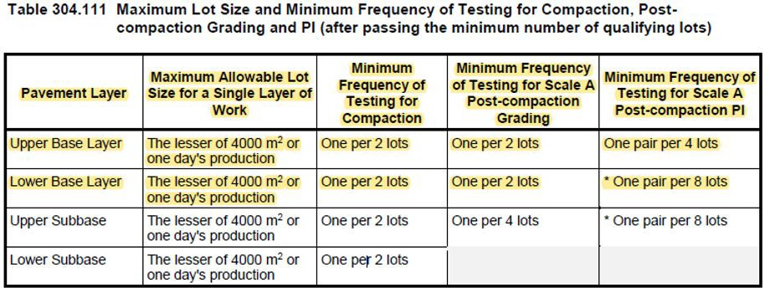

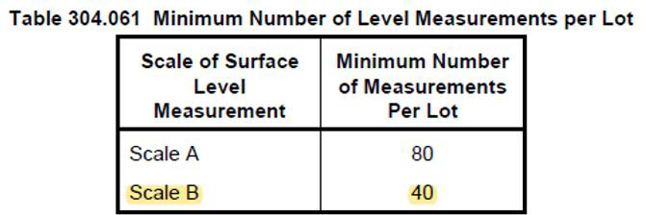

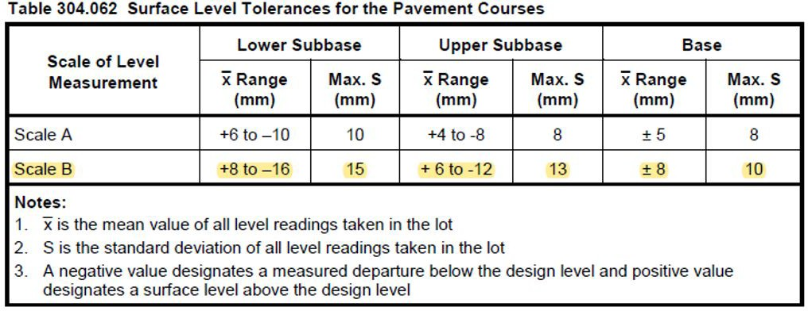

**Photo and video**

**Final Inspection**

(The signature below veriﬁes that this ITP has been completed in accordance with the Fulton Hogan’s Quality system Procedures and veriﬁes lot compliance with speciﬁcations)

**Project Team signature** -

**Photo and video**

**Final Inspection**

(The signature below veriﬁes that this ITP has been completed in accordance with the Fulton Hogan’s Quality system Procedures and veriﬁes lot compliance with speciﬁcations)

**Client Signature** -